PIZZA SALES SQL QUERIES
A.KPI’S
1.TOTAL REVENUE:
select sum(total_price) as total_revenue from pizzasales;
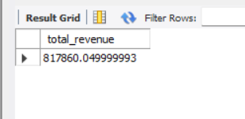
2.AVERAGE ORDER VALUE
select sum(total_price)/count(distinct order_id) as avg_order_value from pizzasales;
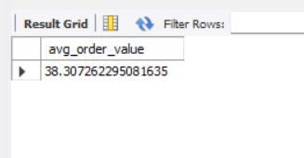
3.TOTAL PIZZA SOLD
select sum(quantity) as total_pizza_sold from pizzasales;
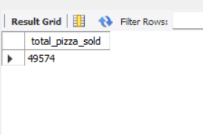
4.TOTAL ORDERS
select count(distinct order_id) as total_orders from pizzasales;
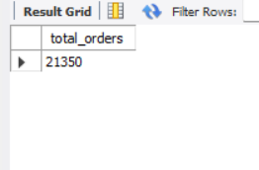
5.AVERAGE PIZZAS PER ORDER
select sum(quantity)/count(distinct order_id) from pizzasales;
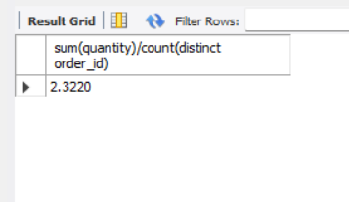
6.DAILY TREND FOR TOTAL ORDERS
SELECT
DAYNAME(STR_TO_DATE(order_date, '%d-%m-%Y')) AS order_day,
COUNT(DISTINCT order_id) AS total_orders
FROM pizzasales
GROUP BY order_day
ORDER BY FIELD(order_day,
'Monday','Tuesday','Wednesday','Thursday','Friday','Saturday','Sunday');
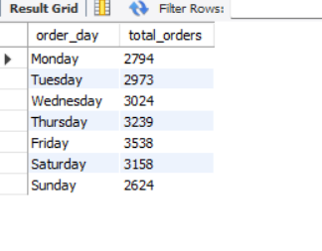
5.MONTHLY TREND FOR TOTAL ORDERS
SELECT
MONTHNAME(STR_TO_DATE(order_date, '%d-%m-%Y')) AS order_month,
COUNT(DISTINCT order_id) AS total_orders
FROM pizzasales
GROUP BY order_month
ORDER BY FIELD(order_month,
'January','February','March','April','May','June',
'July','August','September','October','November','December');
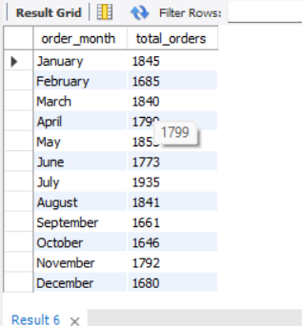
B.DAILY TRENDS FOR TOTAL ORDERS
6.PERCENTAGE OF SALES BY PIZZA CATEGORY

SELECT
pizza_category,
ROUND(
SUM(total_price) * 100 /
(SELECT SUM(total_price)
FROM pizzasales
WHERE MONTH(STR_TO_DATE(order_date, '%d-%m-%Y')) = 1),
2
) AS pct
FROM pizzasales
WHERE MONTH(STR_TO_DATE(order_date, '%d-%m-%Y')) = 1
GROUP BY pizza_category;

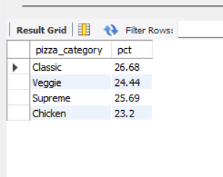
7. PERCENTAGE OF SALES BY PIZZA SIZE

SELECT
pizza_size,
ROUND(
SUM(total_price) * 100 /
(SELECT SUM(total_price)
FROM pizzasales
WHERE MONTH(STR_TO_DATE(order_date, '%d-%m-%Y')) = 1),
2
) AS pct
FROM pizzasales
WHERE MONTH(STR_TO_DATE(order_date, '%d-%m-%Y')) = 1
GROUP BY pizza_size order by pct;

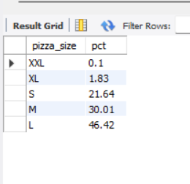

8.TOP 5 BEST SELLERS BY REVENUE,TOTAL QUANTITY AND TOTAL ORDERS
select pizza_name,sum(total_price) as total_revenue from pizzasales
group by pizza_name order by total_revenue desc limit 5;
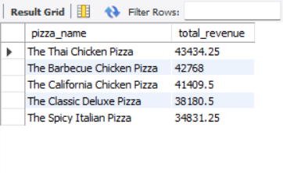
9.BOTTOM 5 PIZZAS

select pizza_name,sum(total_price) as total_revenue from pizzasales
group by pizza_name order by total_revenue asc limit 5;

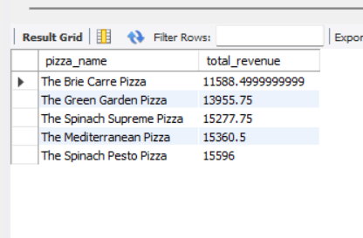

10.TOP 5 PIZZAS BY QUANTITY

select pizza_name,sum(quantity) as total_quantity from pizzasales
group by pizza_name order by total_quantity desc limit 5;

